REGISTERED ORGANISATION APPLICATION FORM

Stewardship/archaeological advice by historic environment services

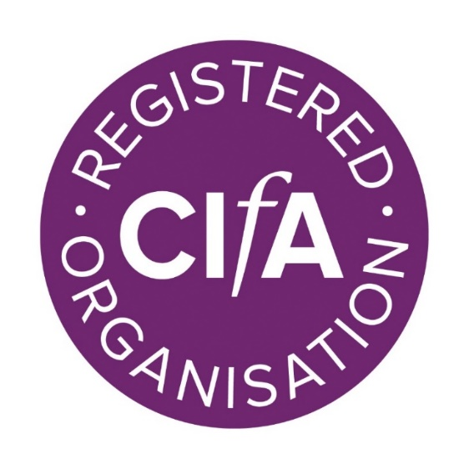

Published April 2025.

This section is to be completed by all organisations that provide archaeological advice to national or local government bodies responsible for implementing planning and heritage consent processes.
How to complete this form
This form is supplementary to the main RO application form, the information provided will form the basis of your inspection report. It will help the inspection panel prepare for their visit. Refer to the Registration of organisations: additional guidance while completing the form.
Within this application form “project design” is used as a universal term for the document that sets out how the archaeological work will be conducted. This document may be called something different depending on the jurisdiction of the work.
If you would like a copy of your previous application form to assist, please get in touch with us to request a copy: ellen.mcnamara@archaeologists.net

Stewardship/archaeological advice by historic environment services

This section is to be completed by all organisations that provide archaeological advice to national or local government bodies responsible for implementing planning and heritage consent processes.
Does your organisation have the following? (Please make available on request) | Yes | No | NA
HER users’ manual and/or data standard | ☐ | ☐ | ☐
HER data audits | ☐ | ☐ | ☐
Policy on access and charging for HERs | ☐ | ☐ | ☐
HER Disaster Plan (compulsory for organisations with an HER) | ☐ | ☐ | ☐
Procedures for maintaining records of advice given and monitoring outcomes | ☐ | ☐ | ☐
Guidelines for the preparation of briefs or specifications | ☐ | ☐ | ☐
Guidelines for monitoring and compliance with standards | ☐ | ☐ | ☐
Management advice and advice on agri-environment schemes | ☐ | ☐ | ☐
Input to Local Development Frameworks and Regional Spatial Strategy policies, and other statutory and national policies (eg AONB, forestry, utilities) | ☐ | ☐ | ☐
Policy on using regional research frameworks, where they exist | ☐ | ☐ | ☐
Other policies, guidelines, or manuals (please specify)  Click or tap here to enter text. | ☐ | ☐ | ☐
If your organisation does not have one or more of the above, please explain why.
Click or tap here to enter text.

If your organisation specifies/requires work, does it require/recommend that the work is done by CIfA Registered Organisations? Require ☐ Recommend ☐
If neither, please give reasons
Click or tap here to enter text.

Does your organisation ensure that project designs comply with the relevant CIfA Standards and guidance? (Project design is used as a universal term for the document that sets out how the archaeological work will be conducted. This document may be called something different depending on the jurisdiction of the work)
Yes ☐ No ☐

If yes, what steps does your organisation take to address project designs that don’t meet CIfA Standards and guidance?
Click or tap here to enter text.

If your organisation monitors historic environment work, how does it ensure that the work undertaken is of appropriate quality / fit for purpose?
Click or tap here to enter text.

If your organisation monitors historic environment work, how does it address issues where the work has not been undertaken to the agreed project design or is not fit for purpose?
Click or tap here to enter text.

When your organisation gives advice to a planning authority, how does it ensure that it complies with national and local guidance?
Click or tap here to enter text.

What measures does your organisation have in place to manage consistency in advice responses and monitoring?
Click or tap here to enter text.

When your organisation gives advice how does it review its effectiveness?
Click or tap here to enter text.

If your organisation includes an SMR or HER, has it been subject to an HER data audit?
Yes ☐ No ☐

If not, is there a programme of work in place to achieve this?
Yes ☐ No ☐

If it has been subject to an HER data audit, what were the recommendations and how are they being implemented?
Click or tap here to enter text.

How does your organisation ensure public access to the HER or information about the historic environment?
Click or tap here to enter text.

How does your organisation require opportunities for public participation and engagement to be incorporated into project designs or projects?
Click or tap here to enter text.

How does your organisation monitor the delivery of post-excavation assessment, analysis and publication to fulfil the agreed project design?
Click or tap here to enter text.

If there are delays in delivery of analysis and publication phases how does your organisation address this?
Click or tap here to enter text.

How does your organisation track the deposition of physical and digital archives in line with the requirements of the agreed project design?
Click or tap here to enter text.

If there are delays in the deposition of physical and digital archives how does your organisation address this?
Click or tap here to enter text.

Additional inspection notes (for the use of the inspection panel)

Standard and guidance for stewardship for the historic environment/Standard and guidance for archaeological advice by historic environment services
Project design is used as a universal term for the document that sets out how the archaeological work will be conducted. This document may be called something different depending on the jurisdiction of the work eg WSI, Programme of Works etc

