Registered Organisation inspections:
Information for organisations

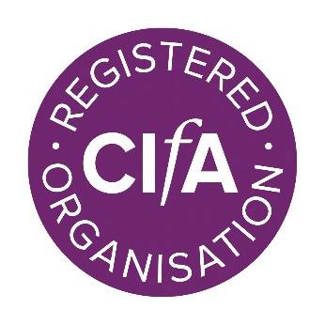
This document covers some common practical questions about the inspection day.
However, we are more than happy to talk you through everything. If you have any questions as we approach the inspection day, please get in touch.

Preparing for the inspection:
We will be in touch to let you know when your organisation is due an inspection and to set a date.
Documents to help you prepare for your inspection can be found on this webpage. Please ensure you have read the Regulations for the registration of organisations. The additional guidance is there to help you understand how to implement the regulations. If you have any questions, please don’t hesitate to get in touch.

Review of reports/documentations:
The RPH is asked to provide a list of grey literature from the last two years. This is for the panel members to select a few for review (in advance of the inspection).

Structure of the day (this can be flexible):
10.00 – 10.30 Introductions and housekeeping
10.30 – 11:30 Project talk through
11:30 – 13:00 Discussion about the organisation
13:00 – 13.30 Lunch
Please provide lunch for the panel
13.30 – 15.00 Office tour (where relevant), speak with staff (may include remote staff)
15.00 – 15.30 Panel discussions
15.30 - 16.00 Feedback to RPH(s) and summing up
The meetings are relatively informal, and discussion based. The CIfA representative will chair the meeting to ensure consistency and to make sure everything is covered.
Panel members will identify areas for questioning in advance. Likely areas for discussion include: the structure of the organisation, staffing and employment, CIfA membership and promotion of the Institute, training and CPD, public benefit, health and safety, quality assurance, commissioning and archives and publications.

Project talk through:
The RPH is asked prior to the inspection, to nominate a member of staff to talk the panel members through a project from start to finish. The inspection panel will suggest a project from your provided list of reports. This is to gain an understanding of the quality assurance processes in place and to understand and assess the procedures that the organisation goes through at different stages in a project.

Talk to staff:
In the afternoon, the panel talk to staff. This will include remote staff where relevant (site staff, staff working from home or in other offices). We find discussions tend to flow more freely if staff are in groups without line management or more senior members of staff. We need to leave the scheduling of staff up to you as it will be very dependent on staff availability. A suggested option for a large organisation is three groups of six planned for 13.30, 14.00 and 14.30.

Site visit (if applicable):
The site visit does not have to be on the day of the inspection. If there is an excavation with a monitoring visit planned, CIfA can contact the historic environment adviser and see if they can also complete our site visit. Alternatively, a panel member or another member in the area can do the site visit. We may also arrange for a facilities visit to be conducted in person, if the inspection has been held remotely. Neither have to be done immediately.

After the inspection:
After the inspection has taken place, the CIfA representative compiles the inspection report which outlines the day and a summary of the discussions. This report is first circulated to the panel members to check and to provide comments or feedback. The report is then sent to the RPH for comment and feedback. Once this process is complete the report is presented to the next available quarterly Registration Committee (Organisations) meeting by the CIfA representative for review. The RCO meetings are in July, September, December and then March.

