COMPLAINT FORM
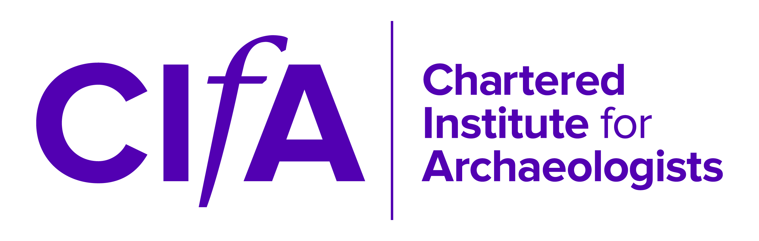
AGAINST CIFA

This procedure applies to complaints against the Chartered Institute for Archaeologists (CIfA) including the NVQ Assessment Centre and not against an individual member, Registered Organisation or the Board of Directors as a whole. Please read the relevant complaint procedure before competing this form.

- COMPLAINANT DETAILS

Name:

Address:

Telephone number:

Email address:

Date complaint submitted:

2. SUMMARY OF COMPLAINT
Please summarise the issues covered by your complaint

3. STAFF/COMMITTEE MEMBER INVOLVED
If your complaint involves a staff/committee member/NVQ assessor, please provide their name

4. FURTHER INFORMATION

Please attach a statement giving details of incidents or behaviour, and supply all relevant names, dates or other information which may help the Institute investigate. Please cross-refer to any supporting documents you are submitting.

How many sheets of your statement are enclosed?………………………………..

How many sheets of supporting documents are enclosed?……………..…………...

5. STATEMENT

I understand and agree that:

    - I have read the complaints procedure relating to complaints made against CIfA

    - Any part of my submission may be discussed with any individual named within it.

    - CIfA will attempt to maintain the confidentiality of complaints at all times and expects the complainant to do the same. A breach in confidentiality may result in the complaint being dismissed by CIfA

Signed……………………………………………….. Date…………………………….

Please return the competed form and supporting information to admin@archaeologists.net

