
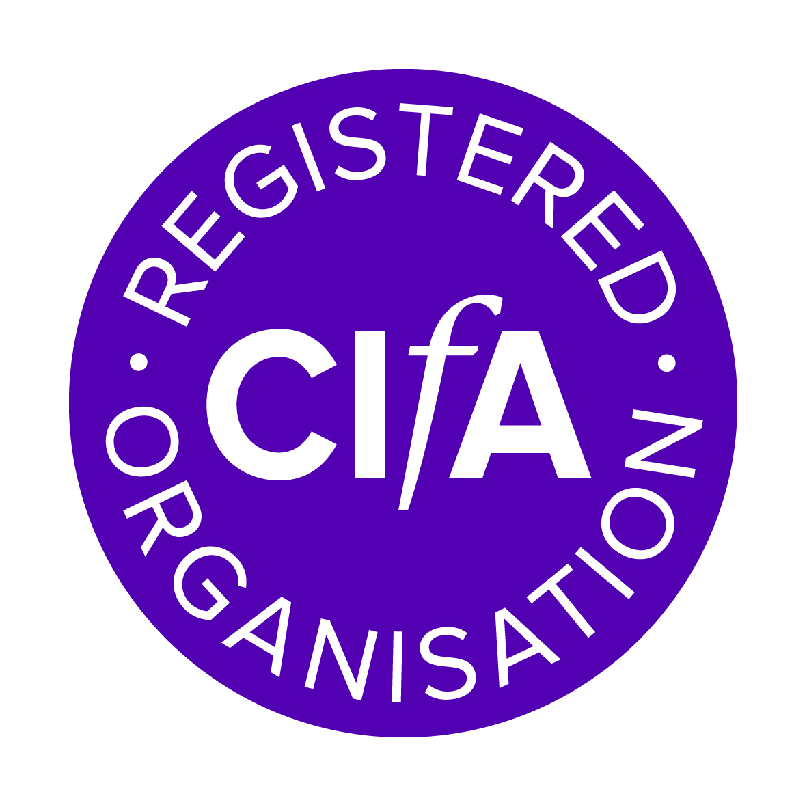

Registered Organisations annual update form

Your organisation has either been inspected very recently or is due to be inspected in the subsequent registration period.
This form requests an update on any major changes to the previous registration application, and a summary of improvements made with reference to any recommendations from the previous registration.
Please ensure this form is completed and returned to us by no later than 1 April 2015
Name of organisation
Address of organisation
Please check the Yearbook data enclosed

Brief description of role of organisation -
Has there been any major changes in the organisations role or activities since the previous application for registration?
Have there been any major changes in organisational structure since the previous application for registration?
Organisation Organogram supplied
Name of RPH
the person who has the highest level of specifically historic environment responsibility within the management structure of an organisation
Name of RPH2
Employment package
For details of the CIfA employment package see www.archaeologists.net/practices/salary
Will you paying at or above the new minimum salary for 2015-16 from 1 April 2015?
PCIfA £17,299 Yes/No salary range is
ACIfA £20,150 Yes/No salary range is
MCIfA £26,045 Yes/No salary range is
What is your employer’s contribution to staff pensions %
Do you pay sick pay to all staff Yes No For some
Are all staff entitled to the statutory 28 days holidays Yes No For some
What hours are your working week (exc, lunch breaks)
In cases where any of the above are less than the requirements set out in the CIfA employment package do you compensate staff accordingly Yes No For some
CIfA membership
Total number of members staff
Number of staff who are CIfA members
Practitioner (PCIfA) Associate (ACIfA) Member (MCIfA)
Non accredited
Number of staff in each office
Main office
Office name – number of staff
Office 2 –
Office 3 –
Office 4–
Actions on recommendations and/or conditions
Please let us know how you dealt with any registration recommendations and conditions made at or since your last registration.
If your organisation didn’t receive any recommendations how has your organisation improved since your last registration?
Contributions to the historic environment and the profession
Please note any additional benefits your organisation/staff contributed to the historic environment profession in the last three years (eg work on committees and working parties, public presentation and outreach activities, care of monuments, relevant research). Instead of providing a list you may enclose a copy of your Annual Report or refer to a relevant website address.
Can CIfA use these activities, in consultation with yourselves, in promotion of the RO scheme?
Yes No

Signed
Contact name
Telephone no
Email

